PROSPECTUS SUPPLEMENT
(To Prospectus dated April, 22nd, 2014)

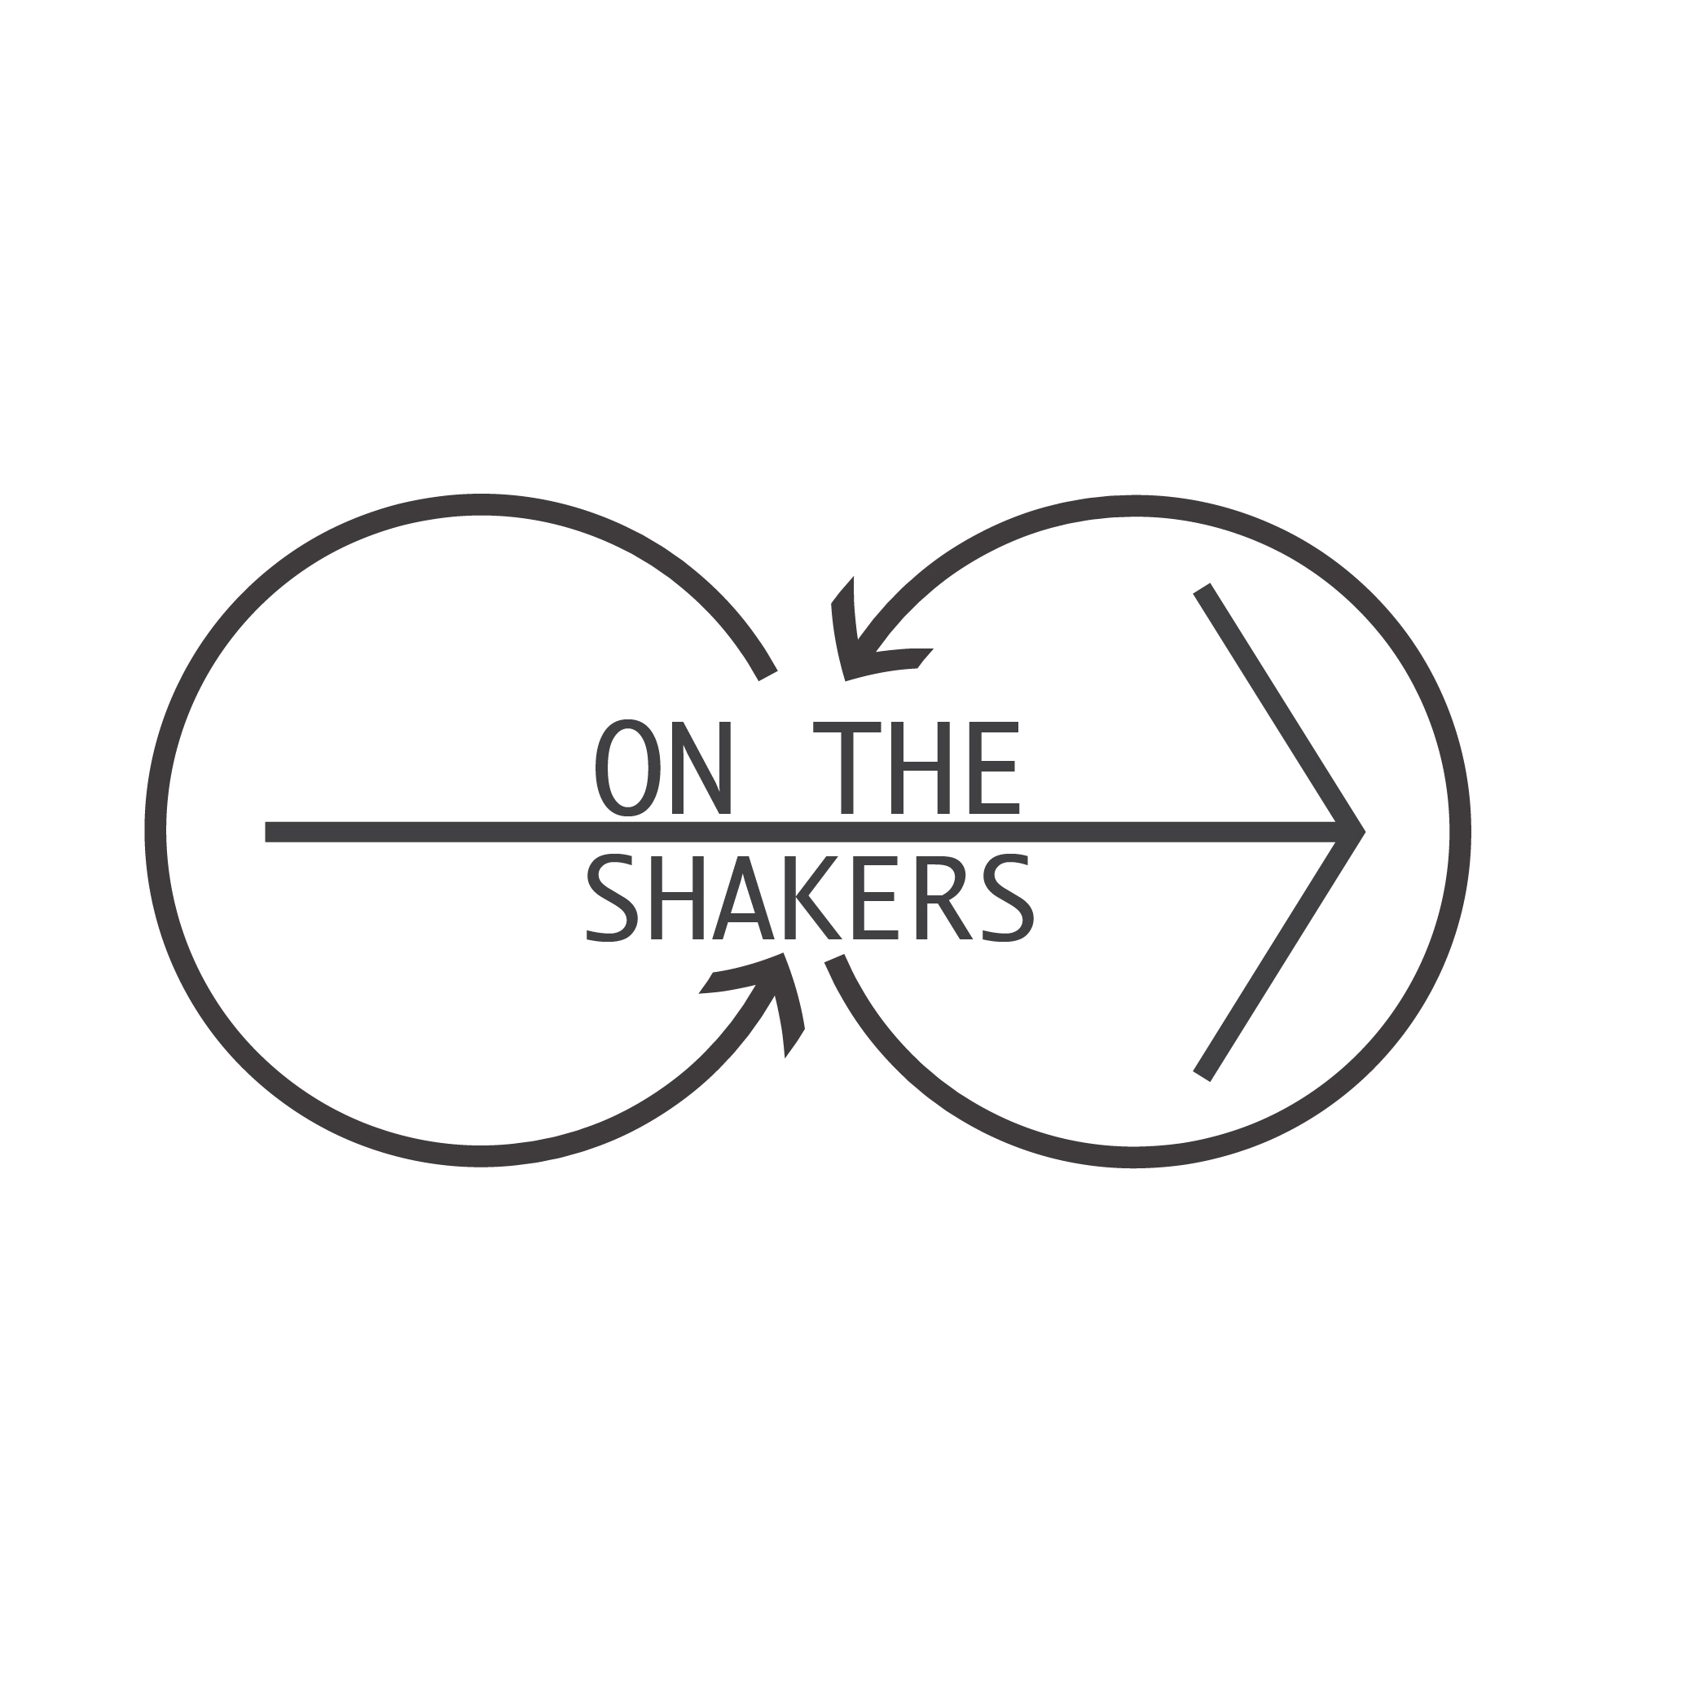
1,000 Shares (Total Amount)
US $70.00/Share

Net Value: US $70,000.00

OTG Shakers, Inc.

This is a plastic electric shaker that holds 16oz of whichever liquid you'd like- hot or cold. It has a perfect leak protection, meaning that you can always have it in your car, in your gym bag or even run with it! Two years in the making, this product is ready to hit the market; now you can prepare shakes or smoothies anywhere at anytime. Our product was made with high-tech machinery and the plastic is BPA & DEHP free, everything is made to precision so there are no flaws or spills. The company creators had been observing society for months, and noticed that people often do not eat or have what their body needs daily, mainly because they are running late and don’t have enough time. For which this product was created, so there are no more worries about time; it is a concept society has invented and there is no need to stress around it!

There is no other company in the market with a product like ours, with the innovative OTG Shaker®, the costumer is able to take ingredients and make a shake or smoothie anywhere! There are many shakers out there, but none like the OTG Shakers®! This product will make the perfect smoothie or shake, and you won’t have the disgusting experience of swallowing big chunks of fruits or packed protein with our top strainer. Don’t hesitate on buying our product, you won’t regret it, and if you do you’ll get a 25% of your invest back!

J. P. MORGAN CHASE

